Liu Mo₇₂Fe₃₀ Black Berry Structure AUC Report

Introduction:
Analytical ultracentrifugation (AUC) is a first principle technique that characterizes the hydrodynamic transport of macromolecules in aqueous solution. A first-principle method, AUC provides sedimentation- and diffusion coefficients, and partial concentrations of molecular species in a mixture. Using the Stokes-Einstein equation, the diffusion coefficient directly provides hydrodynamic radius, and if the partial specific volume (PSV) is known, molar mass and anisotropy (or the frictional ratio, f/f₀) distributions, can be determined as well. AUC was employed to characterize Mo₇₂Fe₃₀ macroions, and to detect any assembled structures.
Materials and Methods:
Using a ThermoFisher Genesys 50 benchtop spectrophotometer, and scanning from 200-500 nm in a 1 cm quartz cuvette, an absorbance spectrum of the 4.04 pH stock was collected. This stock was then diluted to obtain a concentration of approximately 0.6 OD at 382 nm. Two samples, one diluted with Milli-Q water, and one containing 25 mM NaCl, were prepared. The final concentration for both samples were 0.167 mg/mL Mo₇₂Fe₃₀.
Sedimentation velocity experiments were performed using a Beckman-Coulter Optima AUC instrument at the Canadian Center for Hydrodynamics. All samples were spun in cells assembled with 2-channel epon centerpieces and quartz windows, and run in an An60Ti rotor, and measured at 20 ºC. An initial experiment was spun at 3,000 rpm in order to observe fast moving species, but none were detected. A second run was then performed at 40,000 rpm to measure slower sedimenting species. The 40,000 rpm run was spun for 10 hours. Intensity data was collected and converted to pseudo-absorbance using the UltraScan 4.0 R&D data acquisition module [, ]. A partial specific volume of 0.31 ml/g was assumed based on the density of Mo₇₂Fe₃₀ macroions reported in the project request.
Data Analysis: UltraScan was used to further analyze all data. Models were fitted using the 2-dimensional spectrum analysis (2DSA) [] in a multi-step refinement process to remove time- and radially-invariant noise, as well as to determine the boundary conditions. Refined data were then analyzed by the 2DSA Monte Carlo analysis [] to quantify the effect of stochastic noise on the results. A van Holde – Weischet analysis [] was performed to provide diffusion-corrected sedimentation profiles as integral distributions, facilitating comparisons between similar conditions (water, 25 mM NaCl in this case).
Results:
To compare any sedimentation differences between samples with and without NaCl, an overlay van Holde-Weischet plot was made, plotting the integral sedimentation coefficient distributions for both speces (Figure 1). Both samples show homogeneity, sedimenting around 7 S, with the sample in the 25 mM NaCl solution sedimenting slightly faster.
Frictional ratio distributions as a function of sedimentation coefficients derived from the 2DSA-Monte Carlo analysis are presented as pseudo-3d plots in Figure 2. Homogeneity was again confirmed across both Mo₇₂Fe₃₀ samples. By integration of the region outlined in the red boxes, the average sedimentation and diffusion coefficients, molar masses and frictional ratios are reported (Table 1). Mo₇₂Fe₃₀ in both Milli-Q water and 25 mM NaCl was calculated to be 18.9 kDa, in excellent agreement with the estimated molecular weight of a single macroion, hydrodynamic radii for both species averaged ~1.7 nm. Molecular weight and hydrodynamic radius distributions of both Mo₇₂Fe₃₀ samples, as determined by 2DSA-Monte Carlo analysis, are shown in Figure 3. Both distributions show a single, major peak for both parameters.
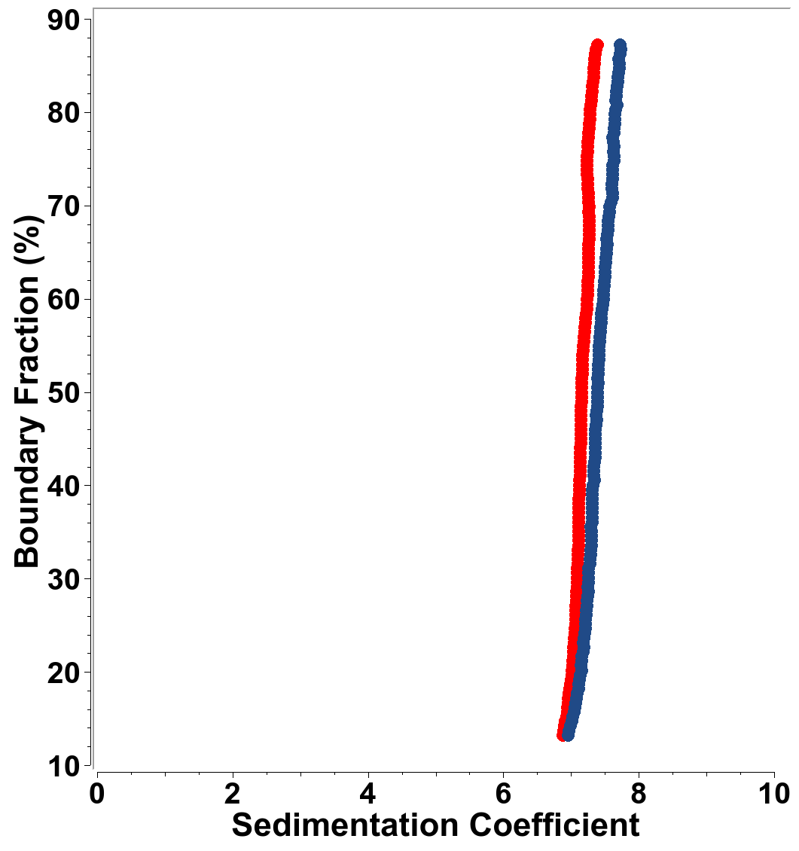Figure 1: van Holde-Weischet plot of integral sedimentation coefficient across the boundary fractions for samples of Mo₇₂Fe₃₀ in Milli-Q (red) and in 25 mM NaCl (blue).

Table 1: 2DSA-Monte Carlo results for Mo₇₂Fe₃₀ in water and 25 mM NaCl:

Sample: | Parameter: | Value: | 95% Confidence Interval
Mo₇₂Fe₃₀ in water: | Molecular weight (Da):  Sedimentation coefficient (s):  Diffusion coefficient (cm²/s):  Frictional ratio:  Partial specific volume (ml/g):  Partial concentration OD₃₈₂:  Hydrodynamic Radius (nm): | 1.8564e+04  7.0883e-13  1.3787e-06  1.2067e+00  3.1000e-01  5.4084e-01  1.7302 nm | (9.3798e+03, 2.7748e+04)  (6.4296e-13, 7.7470e-13)  (8.1557e-07, 1.9419e-06)  (8.4378e-01, 1.5697e+00)  (**constant**)
Mo₇₂Fe₃₀ in 25 mM NaCl | Molecular weight (Da):  Sedimentation coefficient (s):  Diffusion coefficient (cm²/s):  Frictional ratio:  Partial specific volume (ml/g):  Partial concentration OD₃₈₂:  Hydrodynamic Radius (nm): | 2.0111e+04  7.2706e-13  1.3190e-06  1.2352e+00  3.1000e-01  4.5798e-01  1.7709 | (9.7655e+03, 3.0456e+04)  (6.5685e-13, 7.9728e-13)  (7.6446e-07, 1.8735e-06)  (8.6802e-01, 1.6023e+00)  (**constant**)

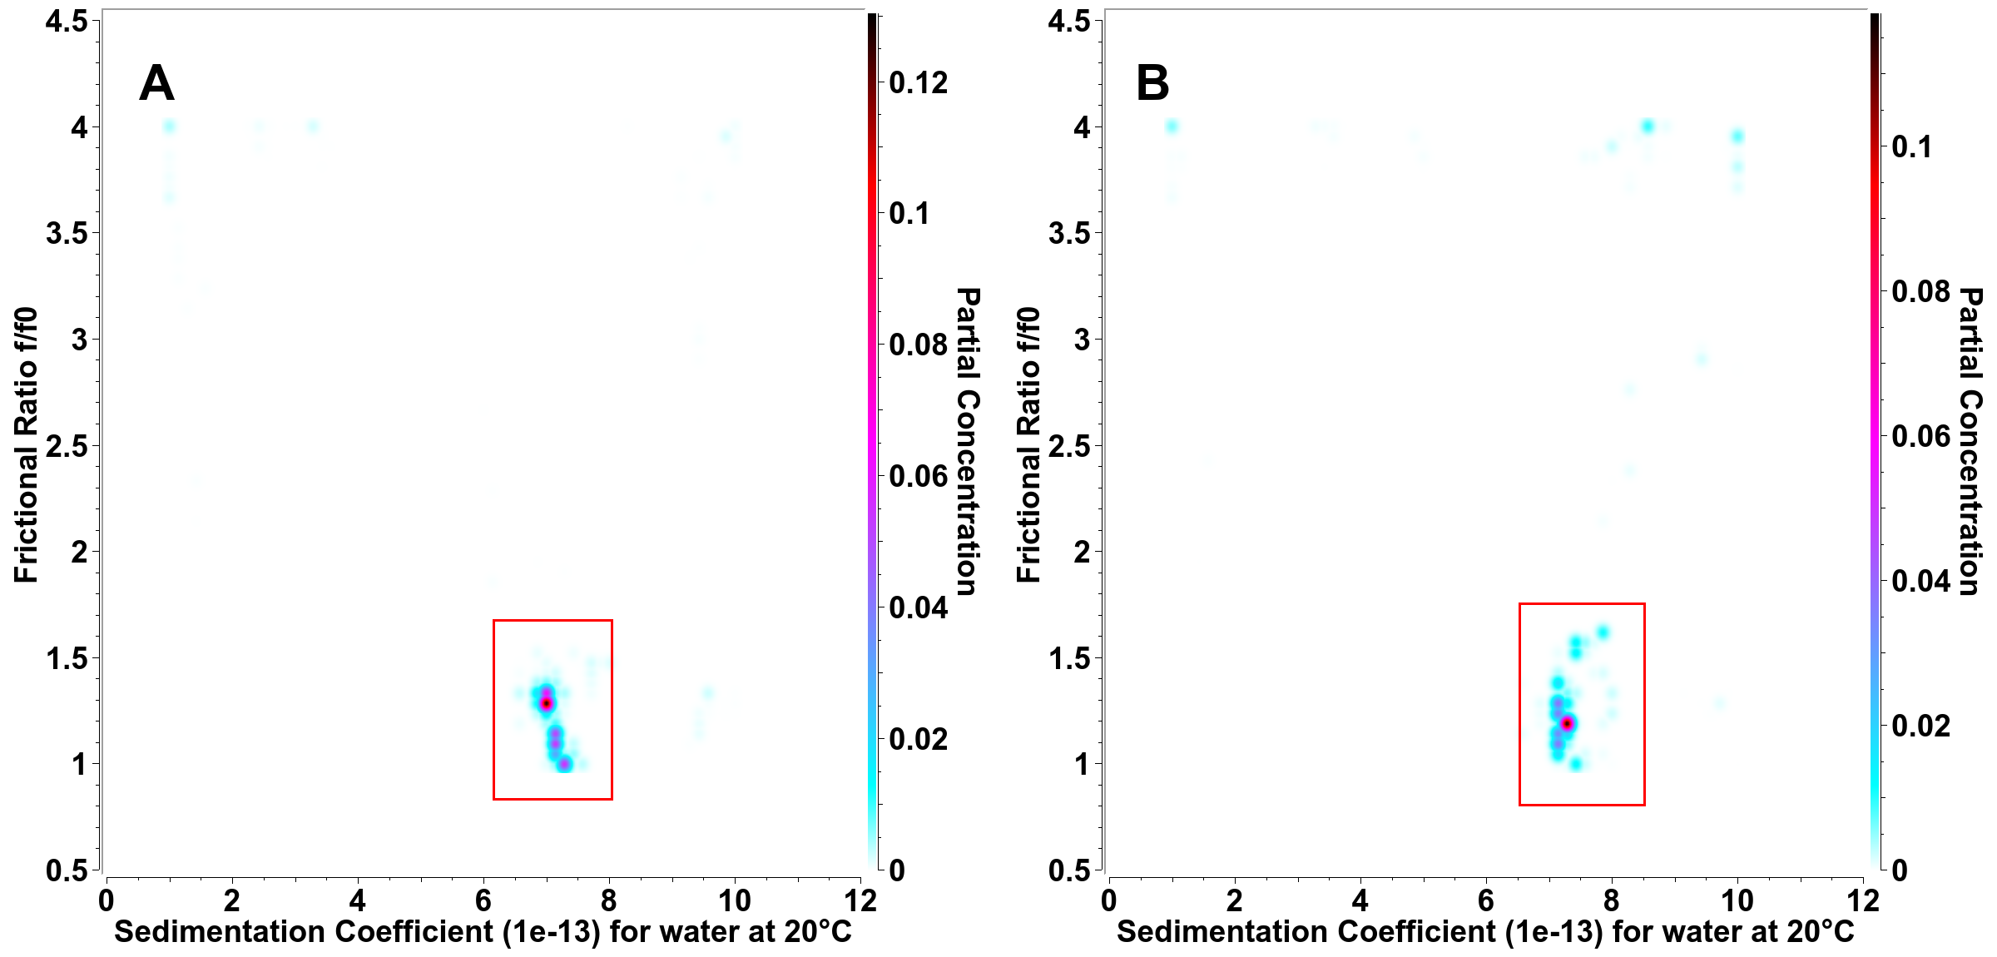
Figure 2: Pseudo-3D plot of the partial concentraions of frictional ratio as a function of sedimentation coefficient for Mo₇₂Fe₃₀ in Milli-Q water (A) and 25 mM NaCl (B). Both samples show homogeneity with similar sedimentation coefficients. The red boxes indicate the sedimentation and diffusion data used to calculate frictional ratio and molecular weight (Table 1)
Discussion:
The species in both samples were found to be only unassembled macroions. Larger species were not observed, indicating self-assembled supramolecular structures are not present. The hydrodynamic radius and observed molar masses are in excellent agreement with the known values for a single Mo₇₂Fe₃₀ []. The slight differences in molar mass and frictional ratio between the macroion in water vs. in NaCl are explained by invalid assumptions of the partial specific volume to be constant for both solution conditions. In water, the ionic character of Mo₇₂Fe₃₀ will create a larger hydration shell compared to Mo₇₂Fe₃₀ in the presence of counterions, which balance any existing charges, reducing the size of the hydration shell. The apparent PSV in water is expected to be slightly larger than in the presence of counterions. Due to the higher density of counterions than water, the reverse would be expected for the sample in the presence of NaCl. A higher density in the presence of counterions also explains the slight increase in sedimentation coefficient observed in the van Holde – Weischet plot (Figure 1). When adjusting the PSV for the molar mass given in the project request (18,652 g/mol), a PSV of 0.281 ml/g would be expected for the sample in the presence of salt, while a value of 0.33 ml/g would be predicted for the sample in water.
The experimental data fits provided excellent RMSD values, suggesting a high confidence in the results. Frictional ratios reported in Table 1 suggest a nearly spherical shape (adjusted to 1.15 for Mo₇₂Fe₃₀ in water, and 1.27 in the presence of counterions, consistent with a hydrated icosadodecahedron geometry. Surface roughness will cause the value to slightly deviate from 1.

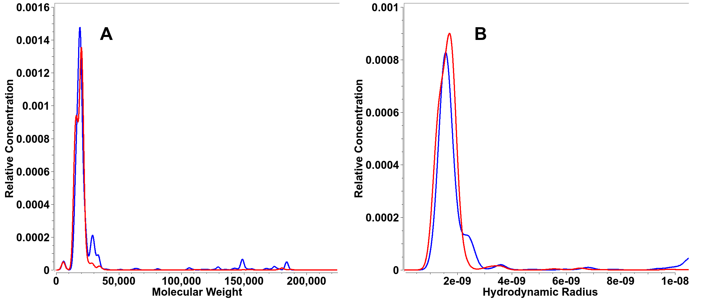
Figure 3: 2-dimensional spectrum analysis Monte Carlo distributions for molecular weight (A) and hydrodynamic radius distributions (B) for Mo₇₂Fe₃₀ in Milli-Q water (red lines) and 25 mM NaCl (blue lines). Samples in Milli-Q show a single species peak with an average radius at ~1.6 nm, while samples in 25 mM NaCl have a larger and more heterogeneous distribution with a mean of ~1.8 nm and a smaller peak at 11 nm.
References:

Demeler B., and G. Gorbet. Analytical Ultracentrifugation Data Analysis with UltraScan-III. Ch. 8, In Analytical Ultracentrifugation: Instrumentation, Software, and Applications. Eds: Uchiyama S., Stafford W. F. and T. Laue. Springer, 119-143 (2016)
Demeler B, Brookes EH, Gorbet GE, Savelyev A, Zollars D, Dubbs B. UltraScan Data Analysis Software for Analytical Ultracentrifugation Experiments and Hydrodynamic Modelling. 2022, https://github.com/ehb54/ultrascan3
Brookes E, Cao W, Demeler B A two-dimensional spectrum analysis for sedimentation velocity experiments of mixtures with heterogeneity in molecular weight and shape. Eur Biophys J. (2010) 39(3):405-14.
Demeler B and E. Brookes. Monte Carlo analysis of sedimentation experiments. Colloid Polym Sci (2008) 286(2) 129-137
Demeler, B. and K.E. van Holde. Sedimentation velocity analysis of highly heterogeneous systems. (2004). Anal. Biochem. Vol 335(2):279-288
Liu T.; Imber B.; Diemann E.;J. Am. Chem. Soc. 2006, 128, 49, 15914–15920 [3] DOI: 10.1039/B604977J (Communication) Chem. Commun., 2006, 3066-3068

